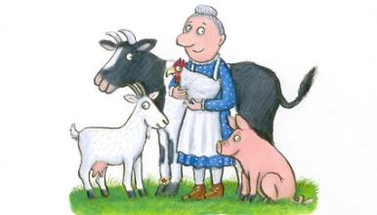A SQUASH AND A SQUEEZE

Once upon a time an old lady lived in a small house on a farm. The old lady had four animals, one horse, one duck, one dog and one cat. The old lady thought that her home was small and said: “My house is a squash and a squeeze”. One day a wise old man from India heard the old lady saying: “My house is a squash and a squeeze”. The wise old man from India said:

-Your house is big.

The old lady said.

-Can you prove it?

-Yes.

So the wise old man from India to prove that the old lady’s house is big, he ordered her to put in the horse. But the horse threw the table and the old lady said:

-Oh my god, what do I have to do? “My house is a squash and a squeeze”.

And the wise old man from India said:

- Ok, take in in your duck.

- Ok, I will take in my duck.

But the duck laid an egg on the carpet.

- Oh my god! What shall I do?

The wise old man from India told the old lady to take in her dog.

But the dog broke the egg.

The old lady said:

- Oh my god, what do I have to do? “My house is a squash and a squeeze”.

This time the wise old man from India said the old lady:

-Take in your cat.

The old lady takes in her cat.

But the cat tore the curtains.

- My house is too small.

- Take them all out! said the old man.

The old lady takes them all out.

- Thank you wise old man from India. You helped me understand that my house is big.

And so they lived happily ever after.

Maria Salamioti

Year 5(2)