***MY ALPHABET***

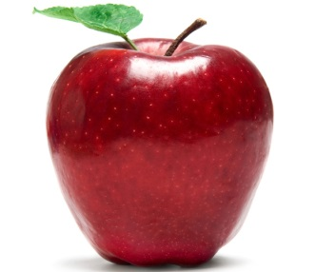

A IS FOR APPLE. I LIKE APPLES.

B IS FOR BLACK. BLACK IS A COLOUR.

C IS FOR COMPUTER. COMPUTERS ARE MACHINES.



D IS FOR DOG. DOGS ARE PETS.

E IS FOR ENGLISH. I LIKE ENGLISH.

F IS FOR FROG. FROGS ARE GREEN.

G IS FOR GIRAFFE. GIRAFFES HAVE LONG LEGS.

H IS FOR HAT. MY HAT IS BIG!

J IS FOR JACKET. MY JACKET IS YELLOW.

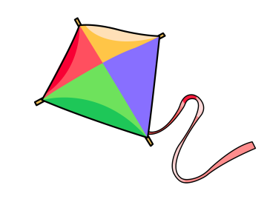

K IS FOR KITES. I’ VE GOT A BIG KITE.

L IS FOR LION. LIONS ARE SCARY.

M IS FOR MUM. MY MUM HAS LONG HAIR.

N IS FOR NOSE. MY NOSE IS BIG!

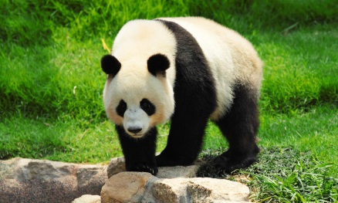

O IS FOR ORANGE. I LIKE ORANGE.

P IS FOR PANDA. PANDAS ARE FAT.

Q IS FOR QUESTION. CAN I MAKE A QUESTION?

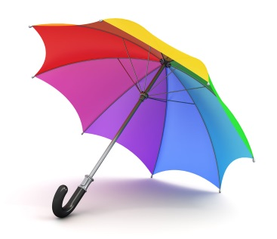

U IS FOR UMBRELLA. I HAVE GOT AN UMBRELLA.

V IS FOR VIOLIN. ΜΥ VIOLIN IS SMALL.

W IS FOR WHITΕ. WHITE IS A COLOUR.

X IS FOR BOX. ΜΥ BOX IS SMALL.

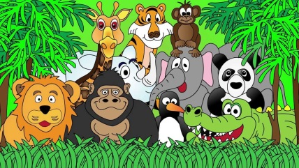

Y IS FOR YELLOW. I LIKE YELLOW.

Z IS FOR ZOO. I LIKE ΤΗΕ ZOO.

RAFAEL NIKOLA

YEAR 4(2)