MYSELF

FRIEN*D*LY

LOVES MUSIC

SLIM

HAS GOT BROWN-BLOND HAIR

NICE

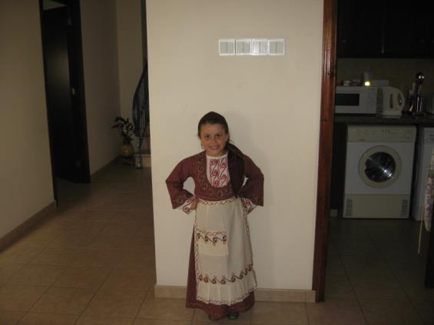

FUNNY

LOVES SWIMMING

HAS GOT TWO BROTHERS

LONG HAIR

Panayiota Savva Year 6(1)