**Myself**

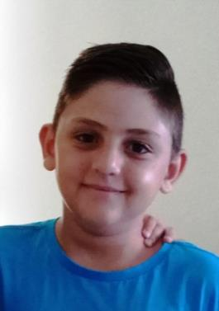

My name is Christos Ttingou.

I’m 11 years old and my brother Gregory is 5.

I live in Sotira village. I go to the 6th grade of Sotira A’ Primary School.

I’m not very tall. I have short brown hair and brown eyes.

I’m kind and polite and I love making new friends.

I like swimming and learning English.

My favourite colors are blue and green.

Christos Ttingou Year 6(2)