MYSELF

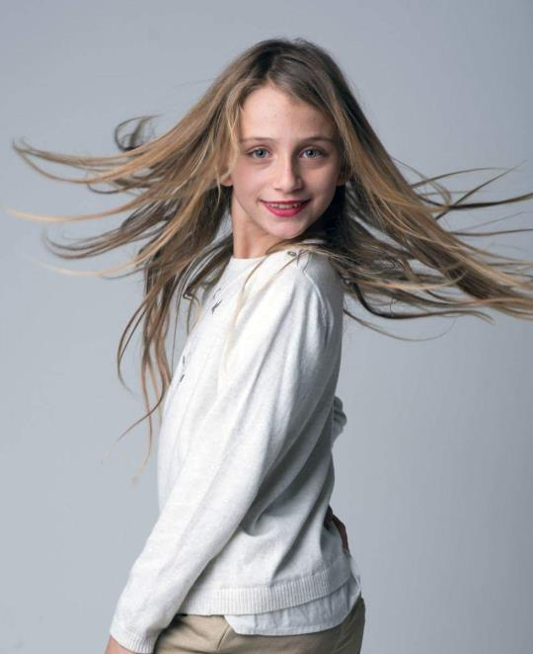blond hair

red lips

long Hair

green eyes

polite

pretty

clever

sweet

funny, drama, dancing, playing football

Irini Strati Year6 (1)